 | The value of the pronumeral is:  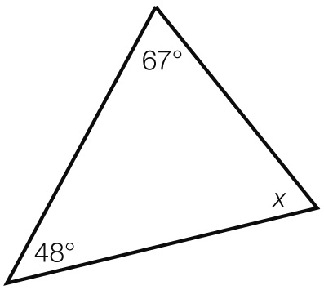  A 115° B 65° C 67° D 245° | 8.1
 | Find the value of the pronumeral.  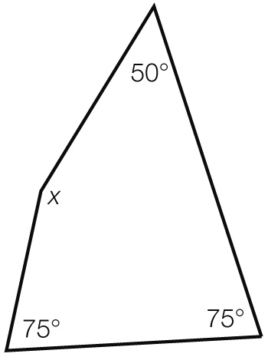  A 75° B 50° C 200° D 160° | 8.2
 | An exterior angle of a triangle is 102°. The two opposite interior angles are a and 47°. The value of a is:  A 55° B 47° C 102° D 149° | 8.2
 | An angle is 289° is:  A acute B reflex  C obtuse D a right angle | 8.1
 | The complement of 74° is:  A 74° B 106° C 286° D 16° | 8.1
 | Corresponding angles on parallel lines:  A are complementary  B are supplementary  C are equal  D add to 360° | 8.1
 | If the hypotenuse and a second side of one right-angled triangle are equal to the hypotenuse and a second side of another right-angled triangle respectively, we say they are congruent because of:  A AAS B SAS C RHS D ASA | 8.4
 | In a kite an angle between two sides of different lengths is 88°. Another angle in the kite must be:  A 92° B 88° C 133° D 272° | 8.5
 | Which statement is true for a kite?  A diagonals bisect each other at right angles  B all angles are right angles  C has no side or diagonal properties  D diagonals intersect at right angles | 8.5
Short answer section

triangle kite rectangle translation reflection rotation  (a) A _______________ has both pairs of opposite sides equal in length.  (b) Another name for a turn is a ________________. |  |  |  | 2
Describe the process of calculating the exterior angle in a triangle if you know the interior angles. Use an example to help you explain.  ________________________________________________________________________________  ________________________________________________________________________________  ________________________________________________________________________________  ________________________________________________________________________________ |  |  |  | 2 | 8.2
For each of the following state whether the angles are complementary or supplementary.  (a) 44° and 46° ________________  (b) 21° and 159° ________________ |  |  |  | 2 | 8.1
Find the value of the pronumeral in each diagram. Give reasons for your answers.  (a) (b)  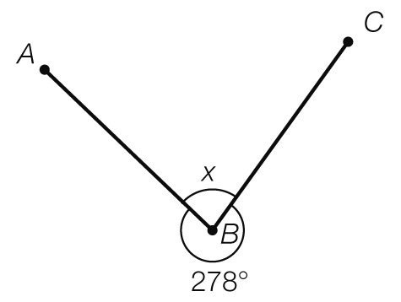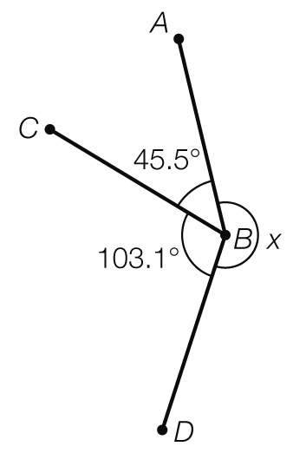 |  |  |  | 4 | 8.1
Find the value of the pronumeral in the following diagram. Give reasons for your answer.  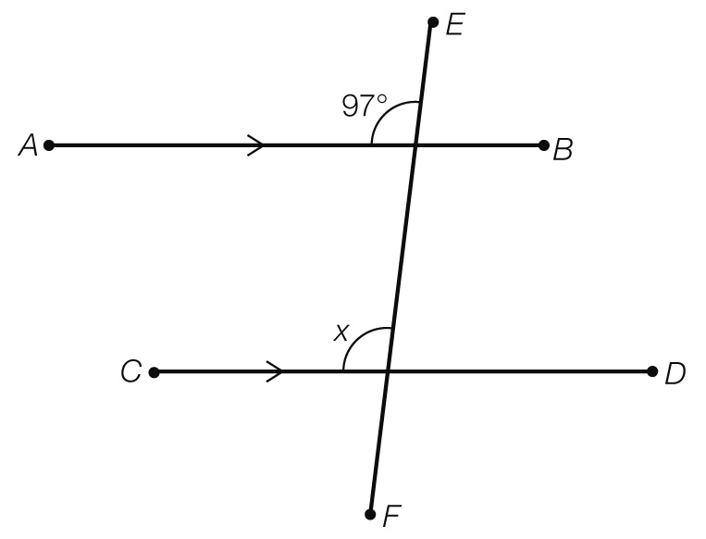 |  |  |  | 2 | 8.1
Find the values of the pronumerals in the following diagram. Give reasons for your answers.  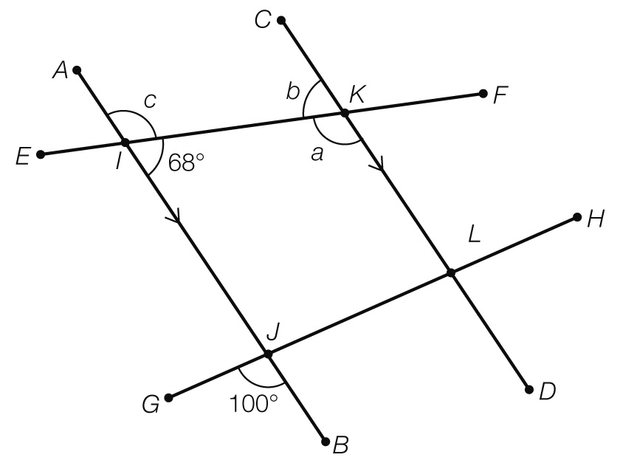 |  |  |  | 6 | 8.1
a and b are supplementary angles. If a is 50° larger than b, what is the size of both angles? |  |  |  | 3 | 8.1
Find the value of the unknown angle in each of the following.  (a) A quadrilateral with angles of 71°, 152°, 74° and x. |  |  |  | 4 | 8.2
(b) A kite with a top angle of 34° and a base angle of 61°.

Find the value of the pronumeral in the following diagram.  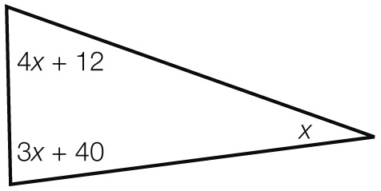 |  |  |  | 2 | 8.2
Find the value of the pronumerals, giving reasons for your answers.  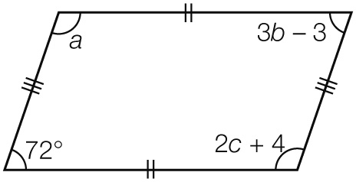 |  |  |  | 6 | 8.2
What is the interior angle sum of a regular decagon? |  |  |  | 2 | 8.2
What is the size of each angle in a regular hexagon? |  |  |  | 3 | 8.2
(a) Plot the points A(-8, 8), B(-8, 5), C(-4, 2) and D(-3, 5). Join the points to form a quadrilateral ABCD and label the points.  (b) Perform the translation of [9, -5] then  (c) Perform a clockwise rotation of 90° about the point C′ , then finally  (d) Perform a reflection in the y-axis. What are the coordinates of the transformed quadrilateral?  A′′′____________ B′′′_____________ C′′′____________ D′′′ ____________  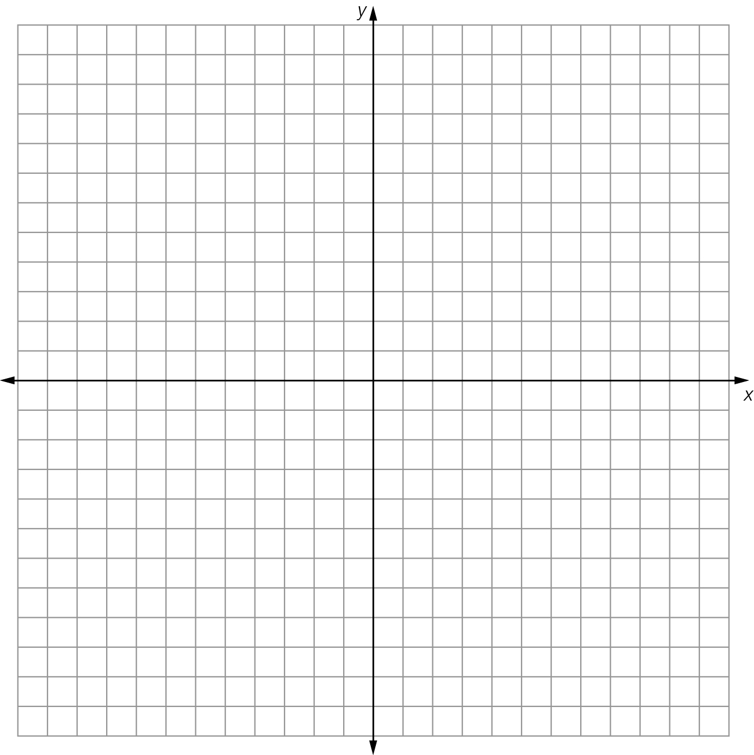 |  |  |  | 6 | 8.3
The figure below is a parallelogram. Name any two pairs of congruent triangles.  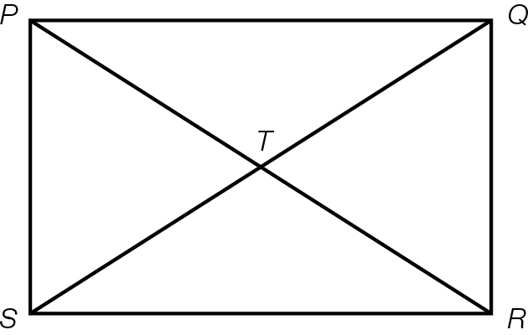 |  |  |  | 2 | 8.3
The following two quadrilaterals are congruent. Use your knowledge of matching angles and side lengths to find the value of the pronumerals.  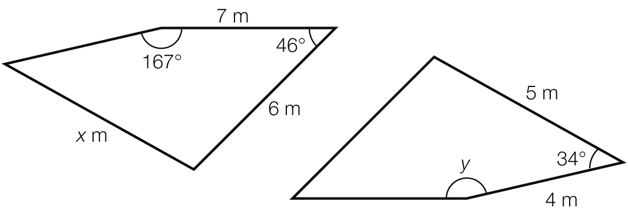 |  |  |  | 2 | 8.3
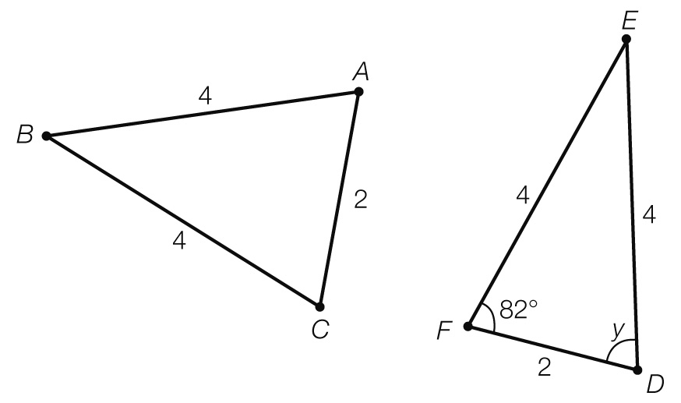  For the following pair of triangles:  (a) show that they are congruent  (b) find the value of the pronumeral. |  |  |  | 3 | 8.4
Use congruent triangles and known angle facts to find the value of the pronumerals in the following quadrilaterals. Give reasons for your answers.  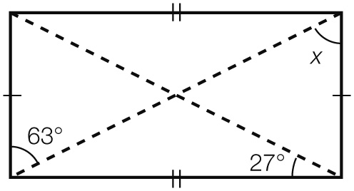 |  |  |  | 2 | 8.5
Extended answer section

A triangle has angles (4x + 14), (3x + 3) and (2x + 10).
Find the size of each angle.

(a) Find the value of the pronumerals in the following quadrilateral. Give reasons for your answers.

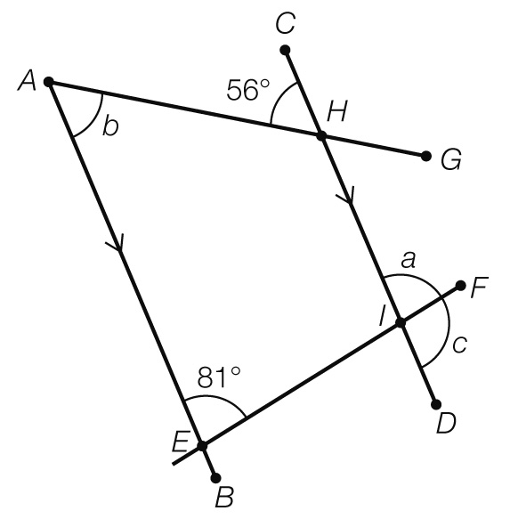

(b) What other angles are equal to ∠FID (or c)?

(c) What is the size of ∠AHI?

